8-BIT SUBTRACTION WITHOUT BORROW

AIM:
To write an assembly language program to subtract two numbers of 8-bit data stored in memory 4200H and 4201H. Store the magnitude of the result in 4202H using 8085 Microprocessor.
APPARATUS REQUIRED:
- 8085 microprocessor kit 1
- Power card 1
- Keyboard 1

ALGORITHM:
- Load the subtrahend (the data to be subtracted) from memory to accumulator and move if to B-register.
- Load the minuend from memory to accumulator.
- Subtract the content of B-register (subtrahend) from the content of accumulator (minuend).
- Store the difference in memory.
- Stop.

Output:
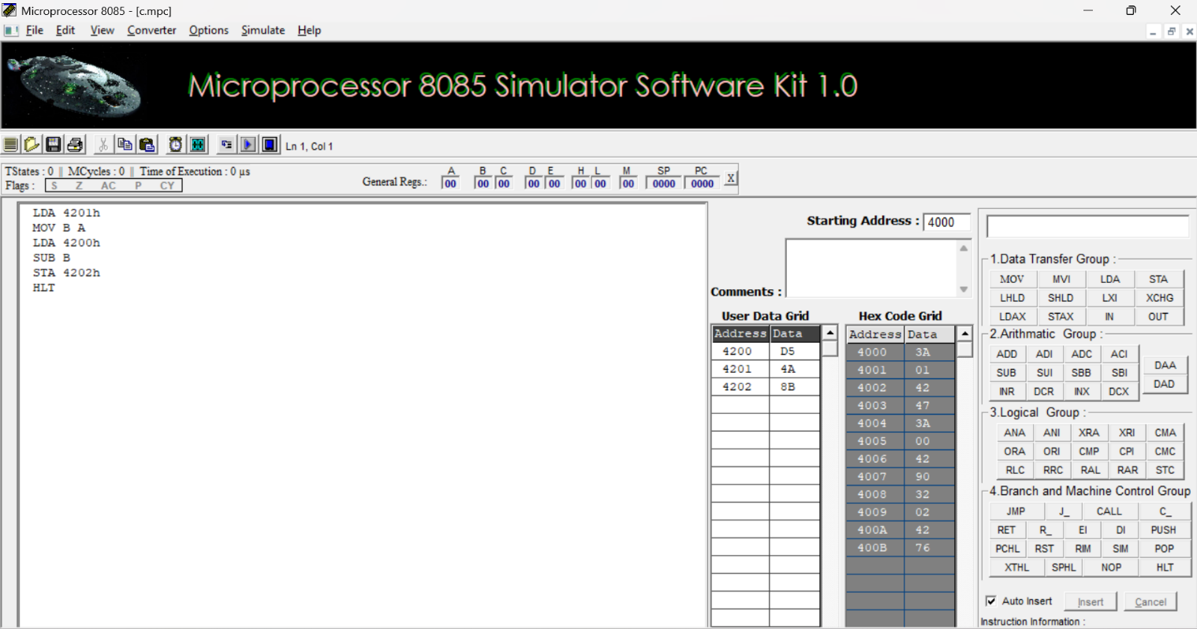

RESULT:
Thus, an assembly language program for subtraction of two 8-bit numbers without borrow was written, executed and Verified the Result successfully using 8085 kit.

